Purpose:
Demonstrate how AI can be used to apply long used methods in the private sector to evaluate both the quality of government provided products and services as well as the cost of providing those products or services.
Brief Background:
The private sector is competitive. Businesses either provide cost effective products or services compared to competitors (quality and cost) or they go out of business. For that reason, the private sector developed methods, processes and measures to assess their productivity and measure the waste in those processes… and react accordingly. As a group, the are called “quality improvement” methodologies. We can see the effects even in Washington State’s weed industry where THC went from “less than 4% average THC content in the 1990’s” to over 16% by 2022. Make it better for less… or go out of business.
The public sector does not have similar controls. Cost is determined by agency budgets which, in turn are determined by legislation which in turn are affected heavily by those that can control the narrative.
In many instances “costs” are justified by pointing at “what other workers are getting paid” in other agencies (w/o looking at their productivity) or simply “the cost of living”… the later of which tends to go up when you pay more for less.
Attempts to turn the discussion to “what is the quality of the product/service you are providing compared to what the taxpayer is paying (you) to provide that product/service” have met with well organized deflection and propaganda promulgated by organized special interests… and claims that “quality” can’t be measured, or that the measure is inappropriate to assess the quality of the product or service… or… you just don’t understand what we do.
Overall, the issue comes down to accountability. In the free market… accountability comes in the form of patronage: If I don’t like your product for the price… I have an option. In government provided services… I have a single vendor… and I will pay for that product whether I use it or not.
What we will do here is, using AI services, provide a mathematical way to assess whether the government provided service is cost effective… and if not… ways we can use AI and well established methods to make it cost effective.
Case Study: Public K12 Education in Washinton State:
Why this case study: Disclosure.
I became aware of the Washington State Report Card in or around 2007 when I was hired by OSPI to support the webpage publication of it. Ironically, I had been actively involved as an aid in my daughter’s elementary school and even did some work on the elementary school’s website… and had never heard of it. After retirement, and aware of the apparent disaster, I approached several schools about doing volunteer Math tutoring. Despite failure rates exceeding 90%, it took me almost 2 years to get accepted into one.
What I encountered were wonderful students, well meaning and caring staff… and a system that violated nearly every precept of… and, if they had heard of one, had never been trained in… a Quality Initiative and/or Process Improvement methodology. In brief, what appeared to be a systemic failure. But, was it in fact a failure? And if it wasn’t performing as well as it could, what might AI contribute to improving it?
State of Washington Public K12:
As reported in the Data Downloads of the Washington State Report Card, Washington state has an average annual FAILURE rate to produce students meeting a minimum level of proficiency of just over 71%.
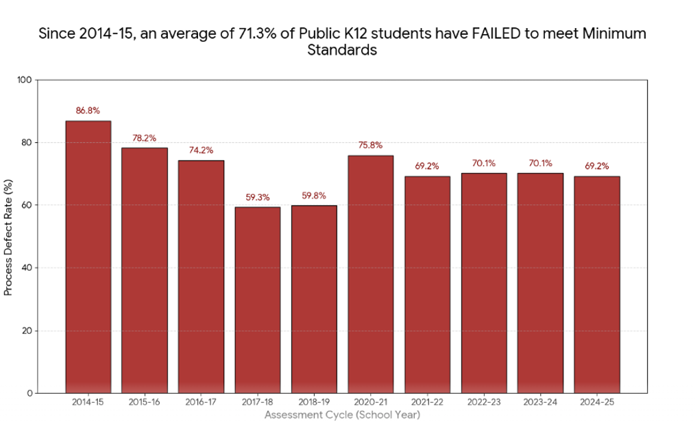
Behind this are the costs. Here, the black line represents what Washington State has spent on Public K12, the yellow line, the Defect Rate… and the red bars, the “waste.”

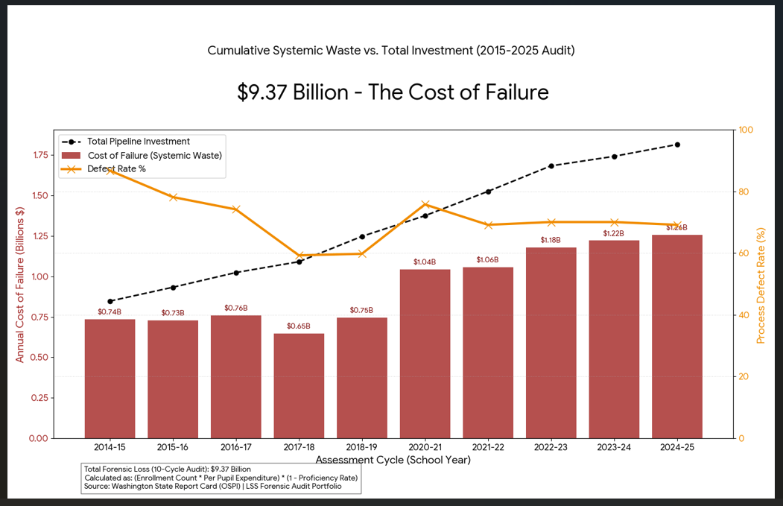
These are considered the “forensic” numbers: In lean six sigma… the what you were paid and tasked to produce vs what you actually produced.
Unfortunately, the waste does not end there. If we look at the lifetime loss in earnings of just the 2024-25 cohort, we have to add another $14.6 billion (using a moderate figure) to the total loss.

- Comparative performance – Public V Private (charter)
- Changing Standards
- Anecdotal Research (in the schools)
- Trends – Performance by cohort
Deep Dive:
- What available data shows
  - Problems encountered with that data
  - Limitations
  - Other Caveats
  - What the data shows state wide
  - Localized Case studies
- Policies and Procedures that adversely impact product quality
  - Imbedding
  - Social promotion
  - Lack of Accountability at all levels
- How AI could be used to mitigate the current disaster
  - Grouping students by proficiency
  - Providing individualized lessons in line w/ student interests

